**Actividad Semana 1**- **Top Ten Most Disastrous Software Bugs**

Arquitectura de computadores. Profesor: Carlos Andrés Díaz

**Paso 1:** Vea el siguiente video donde describen 10 desastres ocasionados por errores de software (Top Ten Most Disastrous Software Bugs)

[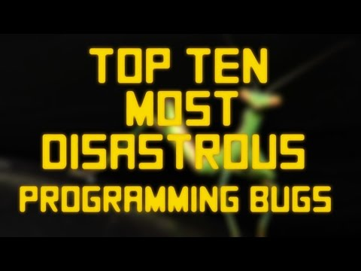](https://www.youtube.com/watch?v=AGI371ht1N8)

**Paso 2:** Seleccione uno de los 10 casos descritos de acuerdo al último digito de su código de estudiante, estudie el caso y explíquelo con sus propias palabras. Es probable que se le pida explicarlo en clase.

#0: [Infamous Software Bugs: AT&T Switches](https://www.olenick.com/blog/articles/infamous-software-bugs-at-t-switches/)

#9: [Launch failure of Mariner I](https://en.wikipedia.org/wiki/Mariner_1)

#8: [Metric Mishap Caused Loss of NASA Orbiter](http://mytoe.org/docs/Mars_closereading_art.pdf)

#7: [Knight Capital Says Trading Glitch Cost It $440 Million](https://engineering.purdue.edu/ee695b/public-web/handouts/References/DependabilityInTheNews/knight_capital_trading_glitch_nytimes_2012.pdf)

#6: [Pentium FDIV bug](https://en.wikipedia.org/wiki/Pentium_FDIV_bug)

#5: [Therac-25 overdoses of radiation](https://www.bugsnag.com/blog/bug-day-race-condition-therac-25)

#4 [Cobalt-60 Disaster](https://www.testbirds.com/blog/historys-biggest-software-fails-cobalt-60-disaster/)

#3: [The Patriot Missile Failure](http://www-users.math.umn.edu/~arnold/disasters/patriot.html)

#2: [Child Support IT failures](https://www.computerworld.com/article/2566427/problems-bedevil-eds-case-management-project-for-u-k--s-child-support-agency.html)

#1: [Ariane 5 Failure](https://around.com/ariane.html)

**Paso 3:** Clasifique el caso estudiando en uno o varios de los siguientes tipos de error que se presentan en computación, puede proponer unas categorías adicionales si así lo considera.

**Error tipo 1:** Machine Numbers, Precision, and Rounding Errors

**Error tipo 2**: Transforming Machine Number Formats: Casts

**Error tipo 3**: Mathematical Modeling and Discretization of the physical phenomenon

**Error tipo 4**: software bugs involving issues of synchronization and Scheduling

**Error tipo 5:** Complexity bugs -Concurrent Computing and Race Conditions

**Bibliografía**

1. [Thomas Huckle](https://www.amazon.com/-/es/s/ref=dp_byline_sr_book_1?ie=UTF8&field-author=Thomas+Huckle&text=Thomas+Huckle&sort=relevancerank&search-alias=books), Bits and Bugs: A Scientific and Historical Review of Software Failures in Computational Science, febrero, 2019.
2. <https://www.youtube.com/watch?v=AGI371ht1N8>